Estimating Ontario’s Growth Potential

Shane Ellard

Department of Economics, York University

ECON 4089: Research Seminar in Economics

Dr. Tsvetanka Karagyozova

April 21st, 2021

Abstract

Potential growth output plays an important role in helping form monetary and fiscal policy. COVID-19 had dramatic effects on the Ontario economy, therefore it is critical to assess the impacts on the long-term potential growth profile. With this is mind, this paper uses a growth accounting approach to estimate Ontario’s potential output growth from 2021 to 2030. I find that between 2021 and 2030 Ontario’s potential output growth averages at 1.64 percent. Contributions from trend labour input and trend labour productivity are similar. In particular, I find that between 2021 and 2030 trend labour input grows at 0.76 percent and trend labour productivity grows at 0.88 percent.

Contents

1. Introduction
2. Literature Review
3. Model Creation
3.1 . . . Growth Accounting
3.2 . . . Modelling Potential Output Growth
4. Estimating the Productivity of Capital
4.1 . . . The Marginal Productivity of Capital
4.2 . . . Total Factor Productivity
5. Labour Input Trends
5.1 . . . Population Growth
5.2 . . . Labour Market Trends
5.3 . . . Trend Labour Input
6. Labour Productivity Trends
6.1 . . . Capital Accumulation
6.2 . . . Trend Labour Productivity
7. Results
7.1 . . . Potential Output Growth: 2021-2030
8. References
8.1 . . . Works Cited
8.2 . . . Stats Canada Data Tables
Appendix A: Robustness Tests
4
5
6
6
7
8
8
10
11
11
12
15
16
16
17
18
18
20
20
21
22

1 Introduction
A central problem faced by macroeconomists is determining the output potential of an economy. The COVID-19 pandemic and issuing lockdowns caused a massive shock to the Ontario economy. In response to this, assessing how the growth potential of the economy has been affected becomes a pressing issue.
Potential output growth refers to the maximum sustainable rate at which an economy can grow, assuming that productive resources are used to their fullest. It plays a central role in many policy decisions. For example, central banks use potential output to calculate to so-called output gap, the difference between actual output and potential output. Using this and other factors such as the inflation rate, they form policy rates to try and stimulate the economy while managing inflationary pressures (Schembri, 2018). The growth potential of an economy also has implications on fiscal policy. For instance, the affordability of future entitlement spending to a large extent relies on output growth. Recall, an economy that grows at 2% per year will double in size after about 36 years, whereas an economy growing at 3% will double in about 24. In the long run, small increases in growth rates have a large compounding effect on output and thus on tax revenues.
Arguably the most important reason to care about potential output growth is to understand how the standard of living is improving. Given some population trend, as the growth rate in output rises the income per capita rises. All else equal, as peoples’ income rises the standard of living they enjoy also rises. This means that by understanding potential output growth and its proximate determinants policymakers can make decisions to improve these factors.
Will all of that in mind, the goal of this paper to form a baseline estimate for Ontario’s potential output growth for 2021 to 2030. To do this, I will use a growth accounting framework to compose potential output growth from trend labour input and trend labour productivity. I will form the forecasts for labour input and labour productivity with consideration to how they have been affected by the COVID-19 shock.
2 Literature Review
There are three categories of approaches to estimating potential output growth: aggregate approaches, growth accounting approaches and dynamic stochastic general equilibrium approaches (Mishkin, 2007). All three approaches have their benefits and drawbacks. In turns out that typically central banks will use a variety of approaches to estimate potential output growth so they can cross-check the results (Schembri, 2018). In this paper, a growth accounting approach will be used to estimate potential output growth and for that reason it will be the focus of this short literature review.
In his seminal 1957 paper, Solow presented the foundations of growth accounting. Numerous others, such as Jorgenson and Griliches (1967), also played a large role in the early development of growth accounting. Growth accounting itself is simply based on expressing an aggregate production function in terms of growth rates. This allows the growth in output to be expressed as a weighted sum of growth in inputs factors (say, growth in capital, growth in labour, and so on). Normally, this growth accounting decomposition is used to explain the causes of past economic growth. For example, famously, Young (1995) and Krugman (1994) used growth accounting to debate the sources of rapid growth in East Asia. This growth accounting approach can however be easily extended to estimate future potential growth. Specifically, researchers can estimate growth trends in the various input factors and use these to construct and estimate of growth potential. This allows researchers to decompose potential output growth into trend labour input growth and trend labour productivity growth to better understand the growth dynamics in the economy.
While the implementations can be quite sophisticated, modern central banks use growth accounting approaches as one tool to help form potential output growth forecasts. For example, researchers at the Federal Reserve use growth accounting as one economic research tool (Schembri, 2018). Similarly, economists at the Bank of Canada have used growth accounting as one tool to estimate potential output growth (Alexander et al., 2017, Bounajm et al., 2019 and Brouillette et al., 2020).
3 Model Creation
3.1 Growth Accounting
In this paper we start much as Solow did in his 1957 paper. We begin by assuming the economy evolves according to the following production function:
 | $$Y(t)=A(t)∙F(K\left(t\right),L\left(t\right))$$ | ( 1 )
In equation ( 1 ) $Y$ represents output, $K$ represents capital stock used in production, $L$ represents labour input, and $A$ is a multiplicative factor that represents total factor productivity (TFP). For now, TFP can be thought of as a rough measure for technological progress. By totally differentiating ( 1 ) with respect to $t$ and then dividing by $Y$we obtain,
 | $$\frac{\dot{Y}(t)}{Y(t)}=\frac{\dot{A}(t)}{A(t)}+A(t)\frac{∂F}{∂K}\frac{\dot{K}(t)}{Y(t)}+A(t)\frac{∂F}{∂L}\frac{\dot{L}\left(t\right)}{Y\left(t\right)}$$ | ( 2 )

In equation ( 2 ) we adopt dot notation to distinguish derivatives taken with respect to time. Define the marginal product of capital as $ω_{k}(t)= \frac{∂Y}{∂K}\frac{K(t)}{Y(t)}$ and the marginal product of labour as $ω_{l}(t)= \frac{∂Y}{∂L}\frac{L(t)}{Y(t)}$. It is assumed that all output is associated with either $K$ or $L$ and that input factors earn their marginal product. Therefore, we have the condition that $ω_{k}\left(t\right) +ω_{l}\left(t\right)=1.$Substituting these values into equation ( 2 ) we obtain,
 | $$\frac{\dot{Y}(t)}{Y(t)}=\frac{\dot{A}(t)}{A(t)}+ω_{k}(t)\frac{\dot{K}(t)}{K(t)}+ω_{l}(t)\frac{\dot{L}\left(t\right)}{L\left(t\right)}$$ | ( 3 )
Notice, in equation ( 3 ) we have decomposed the instantaneous growth rate of output, $\frac{\dot{Y}(t)}{Y(t)}$, into the sum of its proximate determinants. Namely, the sum of the instantaneous growth rate of capital, $\frac{\dot{K}(t)}{K(t)}$, the instantaneous growth rate of labour, $\frac{\dot{L}\left(t\right)}{L\left(t\right)}$, and the instantaneous growth rate of TFP, $\frac{\dot{A}(t)}{A(t)}$. In practice, data for these variables will consist of the discrete time-series analogues. We therefore express equation ( 3 ) as it’s discrete counterpart,
 | $$\frac{∆Y_{t}}{Y_{t-1}}=ω_{k}\frac{∆K_{t}}{K_{t-1}}+ω_{l}\frac{∆L_{t}}{L_{t-1}}+\frac{∆A_{t}}{A_{t-1}}$$ | ( 4 )
Historical growth rates of $Y_{t}$, $K_{t}$, and $L_{t}$ are relatively straightforward to compute using economic accounts data. However, total factor productivity is unobservable. Instead it is usually computed as the residual of equation ( 4 ), and is turn often called the Solow residual. Specifically, we have the equation
 | $$\frac{∆A_{t}}{A_{t-1}}=\frac{∆Y_{t}}{Y_{t-1}}-ω_{k}\frac{∆K_{t}}{K_{t-1}}-ω_{l}\frac{∆L_{t}}{L_{t-1}}$$ | ( 5 )
Notice, it was earlier mentioned that total factor productivity can be thought of as a rough measure for technological progress. But, as it is mechanically calculated as a residual as in equation ( 4 ) TFP really captures all things that effect growth other than the contributions from capital and labour. Using this equation (or versions thereof) to estimate decompose output into its proximate determinants is the main exercise of growth accounting. In the next section, this simple growth accounting framework is extended to estimate potential output growth.

3.2 Modelling Potential Output Growth
In this paper, potential output growth is constructed as a straightforward extension of the growth accounting framework described in section 3.1. This extension is similar to the approaches taken by Alexander et al., (2017), Bounajm et al., (2019) and Brouillette et al., (2020) in their papers assessing global and Canadian potential output growth. To do this, we continue by using the substitution $ω_{k}=1-ω_{l}$ and a rearrangement of equation ( 4 ) to obtain the following identity,
 | $$\%ΔY_{t}=\%ΔA_{t}+ω_{k} \%Δ{(K}_{t}/L_{t})+\%ΔL_{t}$$ | ( 6 )
In equation ( 6 ) the percentage change in output, $\%ΔY_{t}$, as measured in real GDP, is expressed as a sum of the contributions from labour input growth and labour productivity growth. Labour input growth, $\%ΔL_{t}$, is simply measured as the growth in the total hours worked in an economy. It is calculated as the product of the working population, the employment rate, and the average hours worked per person employed. Labour productivity growth, $\%ΔA_{t}+ω_{k} \%Δ{(K}_{t}/L_{t})$, includes contributions from growth in total factor productivity growth and from capital deepening. Capital deepening is a contribution coming from the ratio of capital per labour input. Then, once an estimate has been formed for the marginal product of capital TFP can be calculated as the Solow residual of equation ( 6 ).
When measuring potential output growth, we are interested in the economy’s output potential assuming that all productive resources are used to their fullest. Because of this, potential labour input and TFP are estimated using their long-term trend level. On the other hand, the actual level of capital stock in an economy limits its productive capacity. This includes the changes capital investment due to economic cycles. For this reason, actual levels of capital stock are used when calculating potential output growth.
Given this, potential output growth is then constructed as the sum of trend labour input, $\overline{L}$, trend total labour productivity, $\overline{A}$, and a contribution from trend capital deepening, $K/\overline{L}$, as follows,
 | $${POG}_{t}=\%Δ{\overline{A}}_{t}+ω_{k} \%Δ{(K}_{t}/{\overline{L}}_{t})+\%Δ{\overline{L}}_{t}$$ | ( 7 )

This key identity, equation ( 7 ), will be the main workhorse we use to construct potential output growth.

4 Estimating the Productivity of Capital

4.1 The Marginal Productivity of Capital
An essential step to implement the growth accounting framework outlined in section 3 is forming an estimate of the marginal product of capital. To form this estimate I use a simple log-log regression of the following form,
 | $ln\left(\frac{Y_{t}}{L_{t}}\right)=β_{0}+β_{1}ln\left(\frac{K_{t}}{L_{t}}\right)+$ $ε_{t}$ | ( 8 )
In this regression the coefficient $β_{1}$ is interpreted as the percent increase of real GDP per hour worked resulting from a one percent increase in capital per labour input. As described in section 3, output is measured using real GDP and capital is measured using year-end net stock. Labour input will be first measured using total workers in the economy. After, we refine this measure of labour input and instead use total hours in the economy.
The regression is first run using data from 1981 to 2019. As data for total hours worked is not available for this time-period, we use total workers as the labour input in its place. Three models are considered: linear depreciation, geometric depreciation, and hyperbolic deprecation. As we can see the models yield similar results:

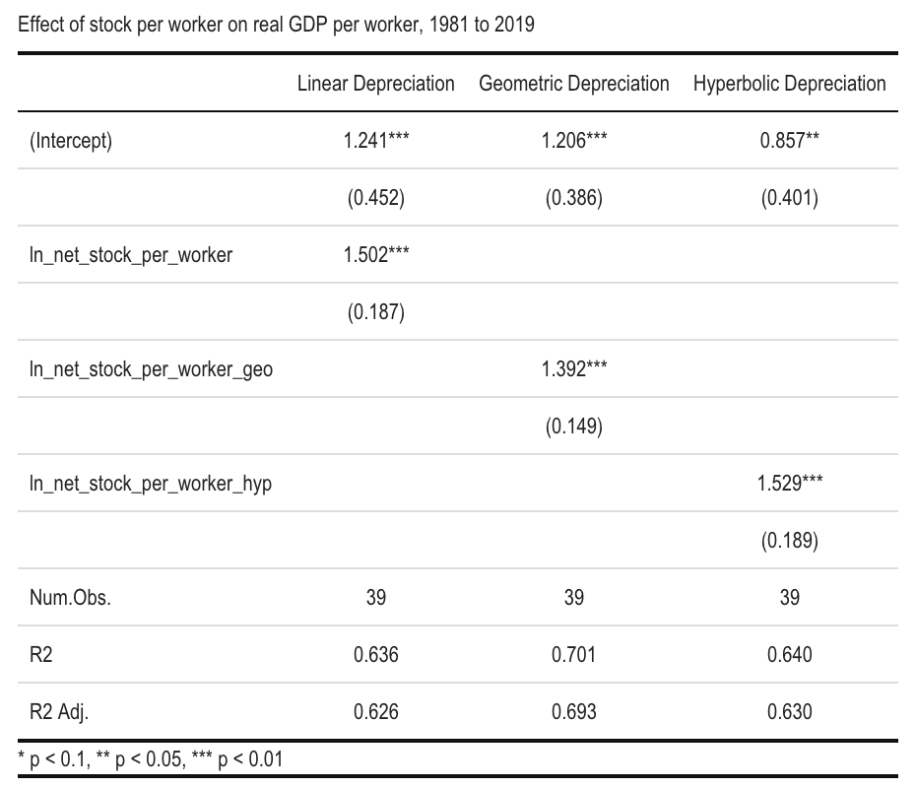

As the level of capital stock in Ontario was relatively low during the 80s it is not too surprising to see such strong returns to capital. There is however a significant concern that as capital stock levels in Ontario are now much higher the marginal productivity will be much lower than in prior decades. With this is mind, we run this same regression using data from the 2000-2019 period. As data on the total hours worked is available for this time-period, we can use this ideal measure rather than total workers. Running this regression using geometric depreciation obtains the following,

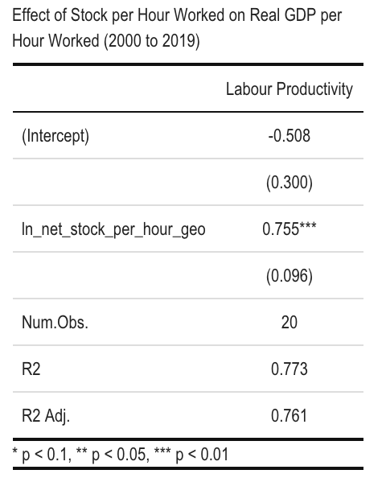

Despite the short sample size this estimate of the marginal product of capital is likely more accurate due to the recency of the data. We are specifically interested in the coefficients estimate equal to 0.755. This coefficient gives us the interpretation that a 1% increase in the level of capital per hour worked results in a 0.755% increase in real GDP per hour worked.

4.1 Total Factor Productivity
We have now found an estimate for the marginal product of capital. Using this estimate along with historical data on real GDP, year-end net stock, and total hours worked we can compute the growth rate in TFP as a Solow residual. This allows us to find the average growth rate of TFP in the past two decades, which we can use as an estimate for the forecast.
This procedure is carried out using data from 2003 to 2019. Over these years growth in TFP contributed about 0.18pp to growth in real GDP. Data from 2000 to 2002 is omitted because in the years 2000 and 2002 there were large outliers in TFP growth. This estimate for TFP growth will be used going forward in forming the reference potential output growth forecast.

5 Labour Input Trends
Annual labour input is the total number of hours worked in an economy in a year. Trend labour input (TLI) is then composed from trends in population growth and trends in the labour market. To abstract away from economic cycles, trends in the labour market are measured by their long-term trend levels. In particular, the trend employment rate (TER) and trend average hours worked per person employed (TAHW) are considered, closely following the approach taken by Brouillette (2020) in measuring trend labour input.
5.1 Population Growth
In the past two decades, Ontario’s working age population has been growing on average at 1.44% per year. This is largely due to immigration. Since 2010, net migration accounted for 72% of the population growth in Ontario. This trend is expected to continue going forward; however, the COVID-19 pandemic and travel restrictions are likely to damper it in the very-short term (MOF, 2020b).
During the summer of 2020, the Ontario Ministry of Finance released their latest population projections for the province. These projections are formed using standard demographic methods and are updated yearly (MOF, 2020a). Preliminary data on the impacts of the COVID-19 pandemic on population growth has been included in their scenarios. The Ministry of Finance released three scenarios, a reference scenario, a low and a high growth scenario. The reference scenario has been used estimating the baseline projection. Below, chart 1 shows this population projection until 2030.

Data from Stats Canada and Ontario Ministry of Finance projections

An important aspect to notice is how quickly the population is aging. In 2010, about 16% of those aged over 15 were of the age 65 or over, by 2030 that share is projected to increase to 25%. This will have important consequences when we soon consider labour market trends within each age group.

5.2 Labour Market Trends
In March 2020, the Ontario government declared a provincial state of emergency to contain the COVID-19 outbreak. Non-essential businesses, as well as schools and childcare centres were ordered closed. This created massive disruptions in the labour market.
During 2020, Ontario lost more than 350,000 jobs − the largest fall in employment on record (FAO, 2021). Most of these losses occurred during March and April when COVID-19 related restrictions first came into place. This sharp fall in employment was felt across the entire economy, but it was most severe for youth and women. During the first 8 months of 2020 the employment rate for those aged 15-19 and 20-24 fell by about 24% and 15% compared to 2019. This is in large part due to service producing industries facing the brunt of economic restrictions, where younger people are more likely to work. For instance, accommodation and food services alone lost about 210,000 jobs between March and April 2020. Also, many of those who did stay employed worked less hours. More than 60,000 workers worked less than half their normal hours, and another 300,000 had their average work hours reduced to almost zero (FAO, 2021).
The closure of schools and childcare centres also created problems. For families with children, new arrangements had to be made to care for children that now were staying home. Such responsibilities are disproportionately taken on by women, whether it be by mothers or other familial caregivers. This effect is reflected in the data, in most age groups the employment rate and average hours worked fell more for women then it did for men. Charts 2 and 3 below display the average percentage decline in the employment rate and hours worked using the first 8 months of 2019 and 2020.

Data from Stats Canada and author’s calculations

Data from Stats Canada and author’s calculations

There is a significant risk these unemployment spells persist into a long-term effect. Consider service producing businesses, which have faced some of the harshest restrictions. These jobs often require a relatively low level of specialization and have historically provided easy entrance into the workforce. However, as these industries and others continue to face harsh economic restrictions hiring activity will likely stay subdued. This will limit opportunities to enter the workforce, reducing the employment experience new workers are able to garner. This loss of work experience may hamper long term employability and lower the potential output profile.
COVID-19 has also incentivized businesses to adopt new technologies in effort to continue delivering goods and services to their customers. Many businesses are automating parts of their operations and moving towards digitization. This will have a strong effect on the shape of the future workforce. For example, during 2020 across all of Canada e-commerce sales grew significantly, largely at the expense of brick-and-mortar stores. As people grow accustomed to the convenience of online shopping it is likely many in-store retail positions will be permanently eliminated (Macklem, 2021). Likewise, more Ontarians are working remotely from home and businesses are questioning the need for large office spaces. The ability to work remotely may help overcome labour market frictions, however it also will influence the demand for transportation, food services, and employees in those sectors (Macklem, 2021).
To account for this I assume that a fraction of the group specific declines in the employment rate and average hours worked persists to lower long term trend levels. This follows the assumption made by Brouillette, et al. (2020) in their reassessment of potential output in Canada. Specifically, I assume that 5% of the observed declined between the first 8 months of 2019 and 2020 is assumed to persist long-term to TER and TAHW.

5.2 Trend Labour Input
Combining the long-term trends in population growth and the labour market I form a projection for trend labour input. As seen in chart 4, throughout the entire forecast trend labour input growth is driven by growth in the working age population.

Data from Stats Canada and author’s calculations

The decline in labour market trends is largely driven by the aging workforce. This is an important consideration because the shifts in the age distribution of the population are slow evolving and cannot easily be changed. This means that we should expect as Ontario’s population keeps growing older into the future these declining labour market trends will continue to persist. Because of this, not only during this forecast but also farther into the future, trend labour input growth will be mostly driven by population growth.

6 Labour Productivity Trends
Trend labour productivity (TLP) is composed from a contribution from capital deepening and from trend total factor productivity. The contribution from capital deepening is the ratio of capital to labour, multiplied by the marginal productivity of capital. Historical total factor productivity is calculated as the residual of equation ( 7 ), as described in section 4.
6.1 Capital Accumulation
The economic slowdown related to COVID-19 and the uncertainty around recovery has had a significant effect on investment. In 2020, total non-residential investment in Ontario fell by about 6% compared to 2019 (Table: 34-10-0163-01). There is a high degree of uncertainty in determining how long this will persist. In the Winter 2020-21 Business Outlook Survey, Ontario firms on average reported positive spending plans and 9.31% of firms planned to invest more in equipment and machinery then the year prior. Many also reported plans to invest in automation, digitization, and in improvement of their customer-facing online business (Business Outlook Survey, 2021a & 2021b). However, this survey was conducted before Ontario’s most recent retightening of economic restrictions. Because of this, the positive spending plans reported might now be overstated. Moreover, businesses in high-contact services such as those in food services and tourism already reported plans to invest less than the year prior (Business Outlook Survey, 2021a). To account for this, I assume that investment numbers stay depressed in the earliest years of the forecast.
While investment will likely stay depressed in the near term it should exhibit a strong rebound once the pandemic is under control and recovery is clearly underway. COVID-19 has in many ways accelerated a transition towards a so-called fourth industrial revolution, characterized by digitization and automation (Macklem, 2021). To model this in the middle stages of the forecast I assume investment grows stronger than its historical average. In the final years of the forecast, I assume that investor sentiment has returned to normal, and the historical average investment is used.

6.2 Trend Labour Productivity
Using the forecast in capital accumulation as well as the marginal productivity of capital and TFP growth we found in section 4, we can construct a labour productivity growth forecast. Below is this forecast for the years 2021 to 2030.

Author’s calculations

Notice that in the early stages of the forecast trend labour productivity is very low. This is due to the very low investment numbers. However, this changes as investment sentiments begin to improve. As is easily seen on chart 5, between 2023 and 2027 trend labour productivity growth rapidly increases, entirely driven by the larger contribution from capital deepening.

7 Results
7.1 Potential Output Growth: 2021-2030
Combining projections for labour input growth and labour productivity growth we can construct a potential output growth forecast. Below, the forecast for Ontario’s potential output growth from 2021 to 2030 is given, decomposed into the contributions from trend labour input and trend labour productivity.

Author’s calculations

Notice how in the early years of the forecast potential output growth is almost entirely driven by labour input growth. This is due to the lowered rates of investment. This weighting then flips in the second half of the forecast as population growth slows down and investment attitudes improve. From 2025 onwards, trend labour productivity becomes the main contributor to potential output growth. Interestingly, if we average across the entire 10 year forecast it is indeed the case that the contributions from trend labour input and trend labour productivity are similar.

Table 1: Ontario’s Potential Output Growth: 2021-2030

It is this diminished labour productivity growth where the effects of COVID-19 are most dramatic. Labour market trends were damaged by COVID-19, but this negative contribution is small relative to the very sharp drop in capital investment. However, if economic recovery quicker than expected, say for example caused by a successful vaccine rollout, these investment attitudes may change rapidly. This would cause a jump in labour productivity and improve the potential output growth profile.
There are in fact many economic uncertainties that future research could address. For instance, it is not clear the how labour productivity parameters will be affected by COVID-19. The transition to remote work could reduce labour market frictions and allow better employee-employer pairings, improving labour productivity. On the other hand, shifts to remote work could plausibly reduce productivity if there are unique benefits to working together in an office space. Studying these questions in-depth would be a valuable future contribution to this subject.

8 References
8.1 Works Cited
Alexander, P., Francis, M., Hajzler, C., Hess, K., Kirby, P., Poirier, L., & Thanabalasingam, S. (2017). Assessing Global Potential Output Growth. Bank of Canada Staff Analytical Note No. 2017-3.
Business Outlook Survey. (2021a, January 11). Business Outlook Survey-Winter 2020–21. Bank of Canada. https://www.bankofcanada.ca/2021/01/business-outlook-survey-winter-2020-21/.
Business Outlook Survey. (2021b, January 11). Business Outlook Survey - data by region (four-quarter moving averages). Bank of Canada . https://www.bankofcanada.ca/publications/bos/business-outlook-survey-data/business-outlook-survey-data-by-region-four-quarter-moving-averages/#chart3.
Bounajm, F., Cayen, J.-P., Francis, M., Hajzler, C., Hess, K., Poulin-Bellisle, G., & Selcuk, P. (2019). Assessing Global Potential Output Growth: April 2019. Bank of Canada Staff Analytical Note No. 2019-13.
Brouillette, D., Champagne, J., Mc Donald-Guimond, J.. (2020). Potential Output in Canada: 2020 Reassessment. Bank of Canada Staff Analytical Note No. 2020-25.
Financial Accountability Office of Ontario (FAO). (2021, February 18). Ontario's Labour Market in 2020. Financial Accountability Office of Ontario (FAO). https://www.fao-on.org/en/Blog/Publications/labour-market-2021.
Jorgenson, D. W., & Griliches, Z. (1967). The Explanation of Productivity Change. The Review of Economic Studies, 34(3), 249. https://doi.org/10.2307/2296675
Krugman, P. (1994). The myth of Asia's miracle. Foreign affairs, 62-78.
Macklem, T. (2021, February 23). Canada's labour market: rebound, recuperation and restructuring. Bank of Canada. https://www.bankofcanada.ca/2021/02/canadas-labour-market-rebound-recuperation-and-restructuring/.
Ministry of Finance (MOF). (2020a). Ontario Population Projections Update, 2019–2046. Ontario Population Projections, 2019–2046. https://www.fin.gov.on.ca/en/economy/demographics/projections/#tables.
Ministry of Finance (MOF). (2020b). Ontario's Long-term Report on the Economy. Ontario, Ministry of Finance. https://files.ontario.ca/mof-long-term-report-book-2020-06-03-en.pdf.
Mishkin, F. S. (2007, May 24). Estimating Potential Output. Board of Governors of the Federal Reserve System. https://www.federalreserve.gov/newsevents/speech/mishkin20070524a.htm#fn8.
Schembri, L. (2018, May). The (Mostly) Long and Short of Potential Output. Ottawa Economics Association and CFA Society Ottawa. Ottawa, Ontario.
Solow, R. M. (1957). Technical Change and the Aggregate Production Function. The Review of Economics and Statistics, 39(3), 312–320. https://doi.org/10.2307/1926047
Young, A. (1995). The tyranny of numbers: confronting the statistical realities of the East Asian
growth experience. The Quarterly Journal of Economics, 110(3), 641-680.

8.2 Stats Canada Data Tables
Table 14-10-0017-01 Labour force characteristics by sex and detailed age group, monthly, unadjusted for seasonality (x 1,000)

Table 14-10-0042-01 Average usual and actual hours worked in a reference week by type of work (full- and part-time), monthly, unadjusted for seasonality

Table 34-10-0163-01 Flows and stocks of fixed non-residential and residential capital, by sector and asset, provincial and territorial (x 1,000,000)

Table 36-10-0489-01 Labour statistics consistent with the System of National Accounts (SNA), by job category and industry

Table 36-10-0096-01 Flows and stocks of fixed non-residential capital, by industry and type of asset, Canada, provinces and territories (x 1,000,000)

Table 36-10-0222-01 Gross domestic product, expenditure-based, provincial and territorial, annual (x 1,000,000)

Appendix A: Robustness Tests

For the regressions described in section 4 to be a valid co-integration relationship we need to verify that the residuals are stationary. The graph below shows the residuals for the first regression described in section 4, using data from 1981 to 2019.

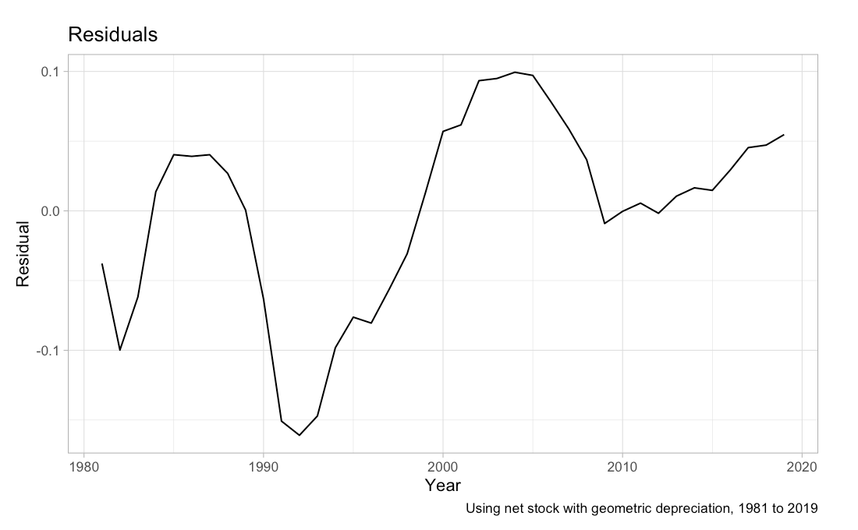
If we perform an Augmented Dickey-Fuller test for this regression we indeed can reject the unit-root null, either almost at the 10% confidence level, or at almost the 5% level if we use a one-sided test.

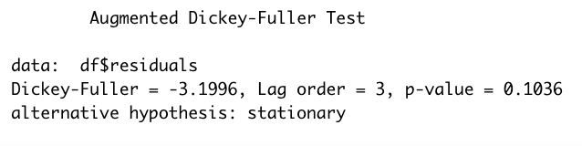
The next graph below shows the residual for the second regression described in section 4, using data from 2000 to 2019.
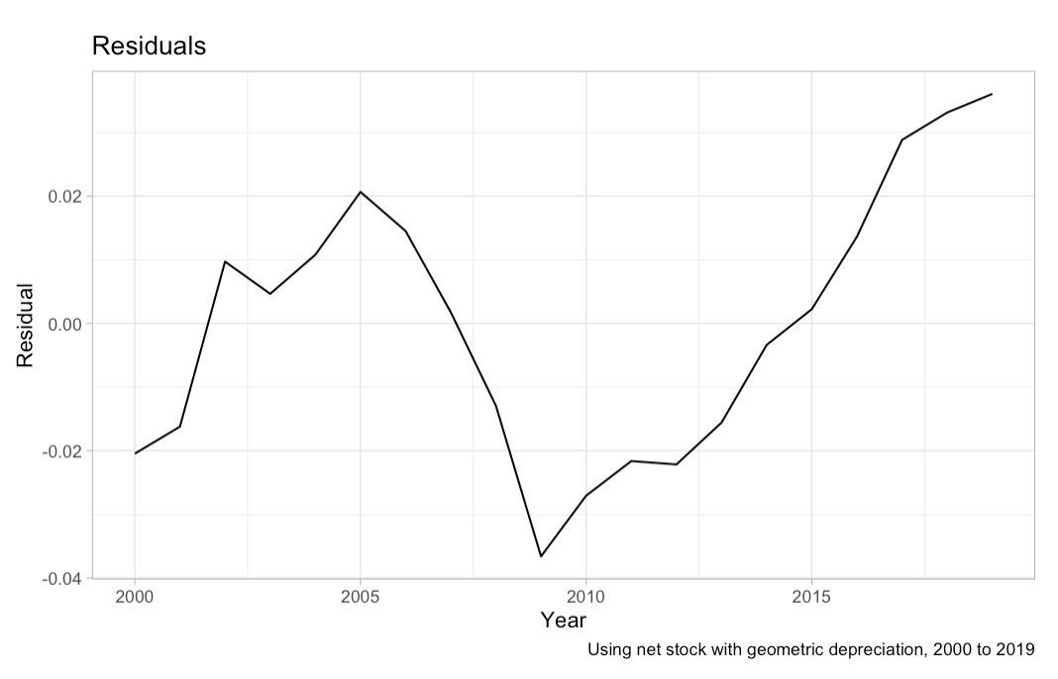
Unfortunately, if we perform an Augmented Dickey-Fuller test for this regression we fail to reject the unit-root null. This result is due to the very short sample size we have used. Despite this second regression obtaining less then fully robust results I will still use the coefficient it yielded, as it is more reflective of today’s contribution to labour productivity.

